The Artificial Intelligence Based solution for Waste Management by Students under Centre of Excellence for ICT in East Africa (CENIT@EA) sponsorship declared first runner-up of ClimateLauchPad Greentech country wise competitions.
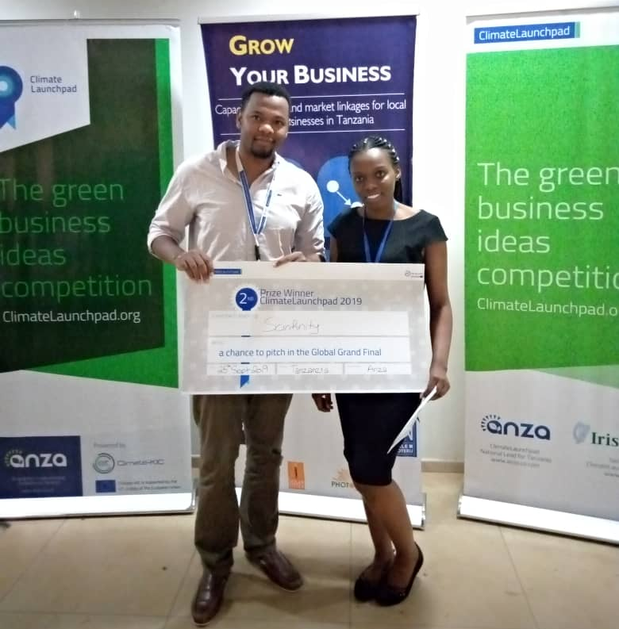
Ms. Shakila Mshana and Mr. Yahya Maalim proudly holding their prize after being declared first runner-up of the ClimateLauchPad Greentech idea competitions held in Dar Es Salaam on September 25, 2019.
CENIT@EA sponsored students for MSc. Embedded and Mobile Systems (EMoS) programme at the Nelson Mandela African Institution of Science and Technology (NM-AIST), emerged the first runner-up in the ClimateLauchPad Greentech idea competitions held in Dar Es Salaam on 25 September, 2019. The two students presented their promising Artificial Intelligence based mechanical System capable of collecting and sorting waste materials basing on their properties.
The solution comes in at the right time where waste management in the East African Region is a big challenge. Most of waste management companies use human labor for collection and sorting of wastes which is inefficient and more costly. The result is that large amount of wastes ends up in the fields and water bodies. This leads to massive land and water pollution therefore the use of artificial Intelligence based system is cost effective, more accurate and environment friendly.
‘’Specifically this system uses Artificial Intelligence (AI) technology to detect properties of wastes and sort them according to their properties. For example all wastes with plastic properties are detected and sorted separately from a huge collection of wastes. From there recycling can take place and so will be to other types of wastes,’’ Ms, Shakila Mshana explained.
As the 2nd finalist team, Mr. Shakira and Mr. Yahya are entitled to compete in the regional finals to be held on 11th and 12th October 2019 in Nairobi Kenya. The winners will get direct entry to the finals at the Global Grand Finals on 14th and 15th of November 2019 in Amsterdam. However; the first and second finalist of country level competitions still qualifies for Global Grand Finals as country representatives. In this case Ms. Shakira Mshana and Mr. Yahya Maalim are assured of their participation to the Global Grand Finals.
Apart from money prize of Global Grand Finals winners that is 1st winner 10,000 Euros 2nd winner 5,000 Euros and 3rd winner 2,000 Euros, top ten global finalists will get direct access to the EIT Climate-KIC accelerator where they will get all the support, tools and resources to fully implement their idea into a business/startup and with the much-needed solution for waste management, in Tanzania and Africa we hope that our team will be among the 10 finalists.
Concurrently, the competition offers an opportunity for participants to advance and promote knowledge and creativity, nurturing intellectual capacity, aesthetic, social and moral growth. This competition is very important for the Centre of Excellence for ICT in East Africa (CENIT@EA) as it’s in line with its Mission and Vision which both promotes enterprising Science, Engineering and Technology innovations. It’s also in line with the objectives the Nelson Mandela African Institution of Science and Technology (NM-AIST) and all partner institutions under the CENIT@EA.
ClimateLaunchPad, competitions are organized by the Anza Business Accelerator, the Tanzania national lead for ClimateLaunchPad, competition which operates globally for showcasing, recognizing and supporting greentech entrepreneurs. It involved a rigorous process that saw only 10 finalists out of 189 applicants from the country. After rigorous training and couching Ms. Shakira and Mr. Yahya emerged as the first runner-up team.

